University of Chicago

Evaluating Bias and Discrimination in Home Mortgage Loan Origination and Pricing

Ryan Winston and Aren Mizuno
DATA 25900: Ethics, Fairness, Responsibility, and Privacy in Data Science
Professor Raul Castro Fernandez
May 17th, 2024
- INTRODUCTION

Historical Background:

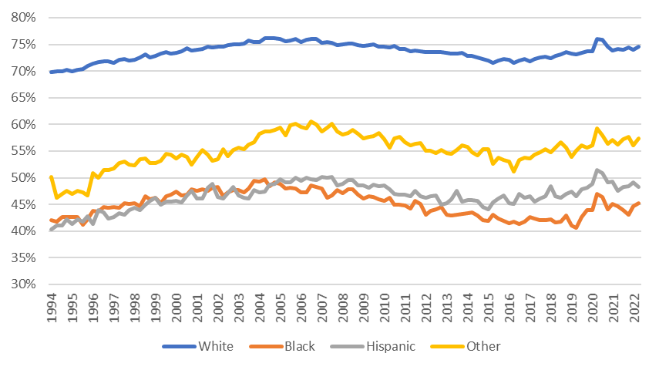

Throughout the United States’ history, certain populations have faced discrimination in many different forms. However, housing inequality carries so many social and economic implications, that one cannot fail to consider whilst analyzing how discrimination has been felt by disenfranchised populations. From a financial perspective, owning one’s own principal residence has historically been one of the most popular long-term investments and has enabled many to build substantial wealth over time. That is not to say that owning a house does not come without risk or have its disadvantages over renting, but few real assets, if any, provide as much utility and return, while also benefiting from favorable tax policies from the government. Moreover, American society has defined individual success, in part, by homeownership, as it is one of the critical aspects of the “American Dream.” With this in mind, one can see how systematic barriers, as well as hidden obstacles, to homeownership against particular groups of people might carry many negative effects. As such, promoting equal access to housing has been a priority of the US government for decades. While the history of housing inequality traces back centuries, one critical advancement within the United States that should have, at least theoretically, ended discriminatory home mortgage lending practices, was the Fair Housing Act (FHA) of 1968. This piece of federal legislation promoted housing equality in many ways, but is relevant to our inquiry into lending discrimination, specifically, as it made it illegal for mortgage lenders to consider race, sex, or national origin, among other characteristics, in the process of giving and pricing a loan. However, the unfortunate reality is that the difference in the proportion of households that own their residence between non-Hispanic whites and racial and ethnic minorities has exhibited no signs of narrowing since 1970, as seen in Figure 4.
Racial Homeownership Gaps Over Time
Figure 1

Existing Research:

While the lack of change in homeownership rates is alarming, one cannot hastily conclude that this alone is proof of the bill or government’s failure. In the time since the FHA was enacted, countless bills, policies, standards, and government (sponsored) agencies have been created to enforce the FHA and promote increased homeownership rates in minority populations. In fact, to promote transparency regarding home mortgage lending, Congress passed the Home Mortgage Disclosure Act (HMDA) in 1975, which made heavily anonymized loan-level data available to the public. Conversely, the US government’s significant efforts to resolve long-standing issues related to homeownership inequality and home mortgage-lending, in particular, do not mean that these issues do not exist anymore.
Given the lack of general consensus regarding the extent of housing discrimination within the US, many scholars have set out to identify, and when possible, quantify the extent of home loan discrimination in regards to loan status (i.e. approved or denied) and loan pricing. As such, researchers often rely on the data released under the HMDA to complete their analysis, as we do in our project. One of the most commonly cited researchers papers, published by Alicia Munnell in 1996, was conducted using HMDA data pertaining to Boston. She came to the conclusion that white applicants with the same personal and property characteristics as minority loan applicants would have an 8% lower probability of having their loan rejected than the minority candidates. This figure continued to be cited for years, and was used as a benchmark for comparison in a later study by Manthos Delis that worked with newer, more abundant HMDA data. In his study, the aforementioned probability of loan rejection had, by 2004-2013, decreased to less than 1%, and the unexplainable difference in the rate spreads that minorities were charged relative to white borrowers had become remarkably smaller, and statistically insignificant.
Considering only those variables contained within the Home Mortgage Disclosure Act (HMDA) dataset, is there bias or discrimination on the basis of race or ethnicity during the home mortgage origination process or in the pricing of originated loans in Illinois? Did the nature or extent of ethnic and racial discrimination during the loan origination and/or pricing process change from 2018-2022?

Question and Relevance:

In light of the economic and social change, as well a new policy from 2018 including loan-level underwriting data in the HMDA data, that has occurred since the time in which Munnell and Delis published their papers, we believe it is worthwhile to evaluate whether discrimination estimates remained in line with Delis estimates and whether the shift in discriminatory practices following the subprime crisis persisted into the present. As such we ask the following questions:
- METHODOLOGY

Cleaning:

Our data was sourced from the HDMA database, an online repository of loan-level, home mortgage data. Using the HMDA website, we selected the datasets from 2018-2022 and filtered them according to the “Loan Purpose” and “Action Taken” variables, such that they only included loans for “Home Purchases,” with statuses of “Loan Originated” or “Application Denied.” This eliminated loans that were withdrawn or never accepted, for example, as well as those taken out to refinance or make improvements to existing properties. This aligns with our goal of exploring bias or discrimination based on gender, race, or ethnicity specifically in home ownership.
Within Python we further isolated the data to fit the scope of our project. We opted to only analyze data from Illinois, by selecting values of “IL,” under the “state_code” variable. Furthermore, we only selected loans with values for “occupancy_type” and “business_or_commercial_purpose” corresponding to “Principal residence” and “Not primarily for a business or commercial Purpose,” respectively. Next, we removed variables that had no relevant value (e.g. “census_tract”) or were redundant, such as the “state_code”. Finally, we removed columns with large amounts of NaN values, as well as outcome variable(s), such as the “rate_spread”.
We then simplified the categorization of race and ethnicity for all applicants and co-applicants by converting values corresponding to specific sub-races and ethnicities into those corresponding to existing, larger racial or ethnic groups in the dataset. Similarly, we converted loans labeled as “Free Form Text Only” under “derived_ethnicity” to “Hispanic or Latino,” as the only write-in option for the ethnicity section of a mortgage application corresponds to the “Other Hispanic or Latino” option. Finally, we removed outliers, which we treated as numerical values greater than Q3 + 1.5 * IQR or less than Q1 - 1.5 * IQR.
Prior to generating dummy variables, we changed the values for all categorical variables from numbers corresponding to categories, into strings that described those categories. We then created dummy variables and dropped select columns accordingly to prevent multicollinearity and establish non-minorities as the baseline for comparison.
At this point, our dataset included dummy variables for both the aggregated, (co)applicant characteristic variables (i.e. those with the “derived” label for (co)applicant characteristics in the original dataset) as well as the standard variables for (co)applicant ethnicity and race (i.e. the non “derived” borrower characteristics). To address potential collinearity, we ran a LASSO and logistic L1 regularization model on three versions of the dataset: one with both types of variables, one with only the aggregated variables, and one with only the standard applicant and co-applicant variables.

Logistic L1 Regression – Loan Origination Methodology:

First, we split the modified dataset into training (80%) and testing (20%) sets, scaled the feature variables, and added constants. We opted to perform logistic regression using the L1 penalty term, or “LASSO” regression, as this method is more likely to shrink variables with minimal effects to take on values of 0, thereby allowing us to prevent overfitting and include only the most important variables in our model. This was particularly important given that our model included many variables and also had an imbalanced class dataset with significantly more approved loans (for every denied loan there are 10 approved loans). Specifically, we performed a LASSO regression with hyperparameter tuning using GridSearchCV on the training data to find the best inverse of the regularization strength (C) with 3-fold cross-validation using 10 evenly spaced c-values on a logarithmic scale between 10⁻³ and 10³. After identifying the optimal c-value based on training set accuracy, we applied the model to the test set data. To interpret the performance of our model, we produced confusion matrices, Receiver Operating Characteristic (ROC) curves, and calculated other performance metrics such as precision, accuracy, F1 score, and recall.

Lasso Regression – Loan Pricing Methodology:

In our analysis focused on quantifying discrimination in loan pricing, which used rate spreads as the target variable as opposed to loan application outcomes, we repeated many of the aforementioned steps. However, since this analysis had an outcome variable only found in completed loans, “rate spread,” we repeated the same testing and training split, except only on the data with an “action_taken” value of “Loan Originated.”
We then LASSO regression with hyperparameter tuning using LassoCV on the training data to find the best regularization strength (alpha) with 5-fold cross-validation using 1000 evenly spaced alpha values on a logarithmic scale between 10⁻⁶ and 10⁶. After identifying the optimal alpha value based on training set accuracy, we applied the model to the test set data. To evaluate this model we looked at the mean absolute error (MAE), mean squared error (MSE), and the test R² score.

- ANALYSIS

Logistic L1 Regression – Loan Origination Analysis:

Model Performance:

All of the logistic l1 regression (both variables, aggregated, and standard) demonstrated exceptionally strong performance scores across all years. Specifically, the test F-1, precision, and recall scores for both classes (0 and 1) ranged between 0.98 and 1, indicating that the models’ predictions were highly accurate and reliable. Additionally, the accuracy score was 1 for all years, meaning the model perfectly classified all instances in the test set for each year.
Furthermore, the test Area Under the Curve (AUC) score was a perfect 1 for all years and models. This means that the binary classification model exhibited perfect discriminatory power, correctly classifying all positive instances as positive and all negative instances as negative across all classification thresholds.
Regarding the confusion matrix, the values were normalized on the whole population and indicated a true positive rate (TP) of approximately 0.9 and a true negative rate (TN) of 0.1 with the FP and FN being less than 0.025 across all years and models. This suggests that there were more true positives than true negatives in the dataset, as indicated by the ratio of approximately 10 approved loans for every 1 denial in the dataset.
The c-values for the years 2018 to 2022 were as follows:
- Combined Variables Model: 0.1, 0.46, 0.46, 0.46, 10
- Aggregated Variables Model: 0.1, 0.46, 2.15, 2.15, 0.46
- Standard (co)applicant Model: 0.1, 0.46, 0.46, 0.46, 10
Across all models, strong regularization is a common feature in 2018, as indicated by the c-value of 0.1. In 2019, all models exhibit weaker regularization with a c-value of 0.46. Between 2020 to 2021, the models with both variables and standard (co)applicant variables maintain a moderate regularization (c-value of 0.46), while the model with aggregated variables has weaker regularization (c-value of 2.15). In 2022, the models with both variables and standard (co)applicant variables show significantly weaker regularization (c-value of 10), whereas the model with aggregated variables strengthens regularization again (c-value of 0.46).

Coefficient Analysis:

The coefficients for our model, which influence the predicted probability of a given applicant’s loan outcome, were highest for the 4 categories of dummy variables corresponding to the purchaser type, HOEPA status, whether the loan is initially payable to the institution, and, finally, debt-to-income ratio. These variable classes consistently had large model importance, as they had high magnitude coefficients, across the years and the feature variables used (all, aggregated/derived, and standard). This makes sense, as many of these variables have a clear relation to a borrower’s default risk, as well a lender’s general risk management policy, which, in conjunction, dictate the loan application outcome. Specifically, the “purchaser_type”, or lack thereof, dummy variables indicate the type entity (e.g. Fannie Mae) that would purchase a loan from the lender, thus having value in explaining the reason for the loan application decision as they also factor in the risk of the loan. The “HOEPA_status” variables reflect whether a mortgage would be high-cost, and therefore subject to more regulation. Given that these types of loan likely come with higher default risk, it is reasonable that carrying this status influences the outcome. “Initially_payable_to_institution” describes whether loan payments would be made directly to the institution, often indicating a more traditional, lower-risk loan structure, which likely influences approval chances, too. Finally, the “debt_to_income_ratio” is representative of the borrower’s financial health, as those with a lower ratio generally have a better capacity to manage and pay off debt, which is the largest consideration a lender makes.
While the aforementioned variables may have had the largest impact on the predicted outcome of our classification model, they do not elucidate any clear and direct association to our inquiry into racial and ethnic discrimination. However, that is not to say that our models found that race and ethnicity were meaningless. Across all of the years and models with different featured variables used (all, aggregated/derived, and standard), we found that there was importance assigned to one’s ethnicity, particularly whether one was Hispanic or white.
Our model was created with a baseline representative of non-Hispanics. As such, holding all else equal, exponentiating the coefficient on a given (co)applicant ethnic variable corresponding to someone ethnically Hispanic yields the odds ratio of a loan being approved for a Hispanic vs. non-Hispanic (co)applicant, with otherwise identical characteristics. As such, negative coefficients on variables such as “applicant_ethnicity-1_Hispanic or Latino” or “derived_ethnicity_Hispanic or Latino” support the claim that the Hispanic applicant face some form of discrimination, as the model implies that one’s loan status is, to a certain degree, informed by ethnicity. Surprisingly, in contrast to the findings from previous studies and our own hypotheses, all of our models from 2018-2020 had coefficients corresponding to Hispanic applicants that were positive and among one of the highest in magnitude relative to other ethnic and racial designations. Specifically, when considering both the “derived_ethnicity” and standard “applicant-ethnicity” together, the odds ratio in favor of Hispanic applicants ranged from 1.233 to 1.3, whereas in 2021 and 2022, the odds-ratio were .9342 and .839, signifying that odds had shifted against them. The pattern of the 2018-2020 data producing an odds-ratio signifying that outcomes were biased in Hispanic applicants favor and the 2021-2022 data suggesting that the odds were in favor of white applicants held true when we considered “derived_ethnicity” and “applicant_ethnicity” independently, as well. The “co-applicant_ethnicity” dummy variables were highly variable and had little impact across all years and models, making it impossible to decipher any meaningful trend.
In evaluating the same categories of variables, except in regards to race (e.g. “derived_race”, “applicant_race”), we witnessed an almost perfect reversal of the trend witnessed in the application approvals among Hispanic applicants. Across all models (those include all the variables, only the aggregated ones, and only the standard ones), we saw that the races with the greatest number of non-zero coefficients were “Asian” and “Black or African American.” For the model containing the “derived_race” and “applicant_race” data together, the odds ratio for 2018-2020 among black applicants and Asian applicants never eclipsed 1.0 and were as low as .94 for both races. However, in 2021 the odds ratio for black and Asian home loan application approval vs. white applicants with otherwise identical characteristics ranged from 1.051 - 1.069 for Asian applicants and 1.026-1.066 for black applicants. In 2022, however, the black applicants, once again experienced a dip in the odds ratio to a range of .927 - .969, whereas the odds ratio shifted further in the Asian applicants favor to 1.152-1.159.

Lasso Regression – Loan Pricing Analysis:

Model Performance:

The model excluding just the derived race and ethnicities variables, the model excluding just the applicant race and ethnicity variables (but including derived race and ethnicity), and the model including them both had nearly identical performance. They exhibited the same Mean Squared Error (MSE) values of 0.0676, 0.0868, 0.0596, 0.0282, and 0.210 from 2018 to 2022, except in 2019, when the combined model had a .002 lower MSE value. Apart from this, they performed equally across this stretch of time when evaluated in terms of Mean Absolute Error (MAE), for which all the models had values of 0.196, 0.226, 0.188, 0.129, 0.353 and for R-squared (R²) values, for which the values were 0.805, 0.753, 0.761, 0.870, and 0.436.
From 2018 to 2022, all three models demonstrated similar trends in their MAE and MSE performance. Specifically, these error statistics initially increased from 2018 to 2019, indicating reduced accuracy, before dropping from 2019 to 2021, implying improved accuracy. However, in 2022 both error statistics increased, once again, to the maximum value within the five year range suggesting that our models fitted on the 2022 rate spread data were the most inaccurate.
The R-squared (R²) values, or the proportion of variation in the rate spreads explainable through our included variables, were relatively high from 2018 to 2021, peaking in 2021, which supports the strength of the models explanatory abilities. However, in 2022, R² values dropped significantly, indicating a decrease in the models’ goodness of fit. This corresponds to the increase in the error statistics.
In summary, the models performed well and improved from 2019 to 2021, but their performance declined in 2022.
The alpha values for the model with both variables from 2018 to 2022 are as follows:

- Combined Variable Model: 0.000127, 0.0000813, 0.000107, 0.0000813, 0.00020244
- Aggregated Variables Model: 0.000116, 0.0000835, 0.000110, 0.0000728, 0.000208
- Standard (co)applicant Model: 0.000110, 0.0000616, 0.0000835, 0.0000748, 0.000192

Several trends can be observed from these values. Firstly, the alpha values across all three models are relatively close each year, indicating a consistent regularization effect regardless of the model configuration. All models exhibit the strongest regularization in 2022, as indicated by the highest alpha values that year. This suggests that the 2022 dataset had patterns or structures that were more complex or prone to overfitting, thus requiring stronger regularization. Conversely, all three models required the weakest regularization in 2019, evidenced by the lowest alpha values. This implies that the 2019 dataset was less complex or noisy, necessitating weaker regularization. Additionally, there is a significant decrease in alpha values from 2018 to 2019 for each model, indicating a decrease in regularization strength, which may reflect a simpler data pattern or less noise in 2019 compared to 2018.

Coefficient Analysis:

The coefficients with the highest absolute values for rate spread were the variables for interest rate, derived loan product type, loan-to-value ratio, loan amount, total loan costs, origination charges, and income. These remained consistent across the years and the different feature variables used (all, aggregated/derived, and standard (co)applicant). These high absolute value coefficients make sense, as these are critical factors for determining the rate spread. The interest rate directly affects the cost of borrowing, with higher rates leading to a higher rate spread. The derived loan product type indicates the nature of the loan, with different products carrying varying risk levels and associated spreads. The loan-to-value ratio shows the amount of the loan compared to the value of the property, with higher ratios indicating higher risk and thus higher rate spreads. The loan amount reflects the size of the loan, with larger amounts often associated with higher spreads due to increased risk. Total loan costs and origination charges are both direct costs associated with obtaining the loan, and higher costs can lead to a higher rate spread as lenders seek to offset their risks and expenses. Finally, the borrower’s income indicates their ability to repay the loan, with higher incomes generally associated with lower risk and thus a lower rate spread. These factors collectively influence the rate spread and are critical in understanding the cost of borrowing for different applicants.
In the dataset with all variables, the “derived_race_black” coefficients showed slight fluctuations but were constantly positive, starting at 0.0094 in 2018 and ending at 0.002459 in 2022. The “applicant_race-1_black” coefficients varied but remained positive, peaking at 0.017084 in 2019 and ending at 0.011492 in 2022. The “co-applicant_race-1_black” values were small but also consistently positive. The “derived_race_asian” coefficients displayed high variability, including negative values, notably dropping to -0.017142 in 2022. The “applicant_race-1_asian” coefficients showed minor fluctuations with a slight negative trend. The “co-applicant_race-1_asian” coefficients were generally positive but small. The “derived_ethnicity_hispanic” coefficients showed mixed results, ending with a negative value of -0.013736 in 2022. The “applicant_ethnicity-1_hispanic” coefficients were mostly positive with some variations, while the “co-applicant_ethnicity-1_hispanic” coefficients showed a consistent increase, ending at 0.012491 in 2022.
In the dataset with aggregated variables, the “derived_race_black” coefficients showed a consistent and positive trend, peaking at 0.019991 in 2020 and ending at 0.015168 in 2022. The “derived_race_asian” coefficients started positive but dropped to -0.01779 in 2022. The “derived_ethnicity_hispanic” coefficients were mostly positive, though they dropped to -0.001288 in 2022.
In the dataset with standard variables, the “applicant_race-1_black” coefficients were all positive and relatively high, peaking at 0.018342 in 2020 and ending at 0.014264 in 2022. The “co-applicant_race-1_black” coefficients remained small but positive. The “applicant_race-1_asian” coefficients showed a predominantly negative trend, dropping to -0.016863 in 2022. The “co-applicant_race-1_asian” coefficients were small and mostly positive. The “applicant_ethnicity-1_hispanic” coefficients were positive but ended with a negative value of -0.004518 in 2022. The “co-applicant_ethnicity-1_hispanic” coefficients were all positive, increasing to 0.011673 in 2022.
Overall, this data shows that co-applicants are less important indicators than applicants or aggregated variables, given the relative size of the coefficients. Furthermore, across the years, 2020 was a peak year for many categories in the dataset with derived data, while 2022 showed a tendency towards negative coefficient trends, especially for Asian and Hispanic values across datasets. Furthermore,
We calculated the percent increase (or decrease when negative) for a change in predictor from the baseline by finding the exponent of the coefficient, subtracting 1, and then multiplying by 100. Since the coefficients for black people were positive in all years and datasets, all the percent increases are also positive. This means that, holding all else constant, a black person had a modest positive increase (0-1.3%) in their rate spread compared to a white person. Hispanic people also mainly had a positive increase, except in 2022. Before 2022, holding all else constant, a Hispanic person had a 0-2.1% increase in their rate spread compared to a non-Hispanic person. Asian people had varying coefficients, but they were mainly negative beginning from 2021. This means that while they generally had a positive change in rate spread compared to white people in earlier years, they experienced decreases in spreads after 2021, holding everything constant.

- DISCUSSION

Challenges and Limitations:

Class Imbalance, Handling of Missing Values, Computational Capacity, Collinearity, Significance of Certain Variables:

While conducting our study, we encountered several limitations due to the wide scope of our project, large dataset with many collinear variables and complex inputs, and the computational capabilities of our computer.
The first challenge we faced in our study was the class imbalance between approved and denied loans in our dataset. From the outset, there was a notable disparity between approved and denied loans, and after cleaning, we had a ratio of approximately 10 approved loans for every 1 denial. This imbalance posed a risk of bias in our model, potentially skewing results towards higher accuracy for loan approvals while underperforming in predicting denials. To address this potential issue, we evaluated the precision, recall, and F1 score metrics for denied loans. The results were impressive, with values ranging from 0.98 to 1, indicating that our model maintained solid performance and was not significantly biased towards loan approvals.
The next challenge we encountered was the handling of rows with NaN values. Since logistic regression cannot process missing values, we had to drop rows with missing inputs from our dataset. To determine if the missing data exhibited random or non-random patterns, we employed the .describe() function to analyze the mean, minimum, standard deviation, and quartiles for any significant differences in numerical columns. This analysis was particularly challenging for categorical variables and was further complicated by the large number of variables in our dataset. Although we did not identify any significant differences, the process was exceedingly tedious and could be considered a limitation of our study.
Another significant limitation in our experiment was the computational ability of our hardware, which proved insufficient for running more intensive regularizations, particularly in the context of logistic regression for the loan origination process. The LASSO regression was particularly demanding, as we conducted 5-fold cross-validation (CV) with 1000 evenly spaced alpha values on a logarithmic scale from 10⁻⁶ to 10⁶. In contrast, our logistic regression used only 3-fold CV. For future experiments, we could enhance the robustness of our model by increasing the number of folds to 5 or 10 and by utilizing a wider range of c-values with more densely spaced intervals.
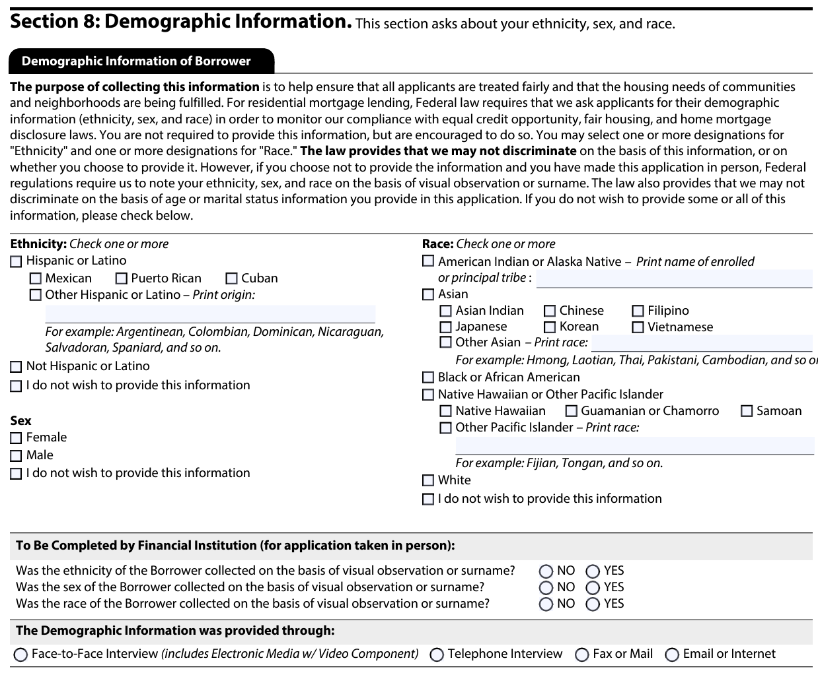
Given the abundance of variables and diverse responses in our dataset, we faced significant threats of collinearity due to the interconnections between variables, such as derived race and applicant race. The “derived” label represents a single aggregated ethnicity/race/sex categorization derived from the individual (co)applicant ethnicity, race, and sex fields, and poses a risk of collinearity. To address this issue, we utilized Lasso regression for its feature selection capabilities, which allowed us to effectively remove many variables. Additionally, we ran our model on three different datasets: one with only derived features, one with only standard variables, and one combining both types of variables. The variable counts for each year are as follows:

Logistic Regression for Loan Approvals/Denials:
- Whole dataset: 80, 130, 119, 127, 162
- Standard variable dataset: 76, 120, 110, 121, 149
- Derived dataset: 76, 117, 136, 139, 101

Lasso Regression for Rate Spread:
- Whole dataset: 137, 143, 129, 136, 133
- Standard variable dataset: 131, 134, 125, 123, 127
- Derived dataset: 128, 125, 118, 121, 125

While using Lasso regression helped prevent collinearity, it also introduced some limitations to our study. Specifically, due to the regularization, we were unable to perform hypothesis tests on the coefficients with the null hypothesis that the coefficients equal zero. We considered bootstrapping our dataset using a model with the optimal alpha or C-value after regularization. Professor Nussbaum, however, advised that this was unnecessary.
Finally, our study did not assess the significance of the coefficients for dummy variables such as “applicant_race/sex_observed” and “applicant_ethnicity-1_Not applicable.” Although we reviewed relevant articles and mortgage forms, we lacked sufficient information to infer the reasons behind these inputs. Moreover, having additional information about the lender would be useful, such as the originator's background, as this would have helped us understand who determined the loan status and whether biases or errors could have been introduced.

- CONCLUSION

The findings on loan origination acceptances and denials revealed mixed results that do not align precisely with other studies. In contrast to previous research, our models from 2018-2020 showed positive coefficients for Hispanic applicants. This indicates that minorities had higher odds of loan approval, contradicting prior studies. In 2021 and 2022, however, the data shifted, and the coefficients became negative, with the odds ratios falling below 1. This suggests that non-Hispanic applicants had lower odds of loan approval, aligning with previous studies.
For Asian and black applicants (the race variables with the greatest number of non-zero coefficients), we observed an almost perfect reversal of the trend seen in Hispanic applicants' approvals. Initially, this trend aligned more with past studies claiming that minority loan applicants face discrimination. In the model containing both “derived_race” and “applicant_race” data, the odds ratios for black and Asian applicants from 2018-2020 never exceeded 1.0 and were as low as 0.94 for both races.
However, in 2021, the odds ratios for black and Asian home loan applications compared to white applicants with otherwise identical characteristics ranged from 1.051-1.069 for Asian applicants and 1.026-1.066 for black applicants. This trend further favored Asian applicants, with odds ratios increasing to 1.152-1.159, contradicting prior studies. In 2022, black applicants experienced a dip in the odds ratios, ranging from 0.927 to 0.969.
In contrast to the loan origination findings, the results for the rate spread align more with previous studies, indicating discrimination. Our analysis found that black applicants consistently had positive coefficients, meaning they faced higher rate spreads compared to white applicants, holding all else constant. This trend also held for Hispanic applicants, except in 2022, when the rate spread percentage change was negative.
Asian applicants had varying coefficients, but they were mainly negative post-2021. In general, Asian applicants appear to have better odds ratios for approved loans and experience a negative percentage change in rate spreads versus the baseline, and relative to other minorities . This trend aligns with broader patterns, such as wealth statistics by race, where Asians often outearn all other races. This suggests that while they generally faced higher rate spreads compared to white applicants in earlier years, they experienced lower rate spreads in later years, aligning with the improved odds ratios that we witnessed for Asian applicants in the loan approval model.
A consistent theme in our findings is the notable shift in 2021, reflected by the changing coefficient direction in both models. This shift could be attributed to COVID-19 and the recession, warranting further research on the pandemic's impact. While we had initially hoped to analyze the impact of the pandemic, due to the waves of COVID-19 and the lag in the economy felt from government spending, we were not able to make much of a connection to our findings.

Bibliography

Delis, M.D., Papadopoulos, P. Mortgage Lending Discrimination Across the U.S.: New Methodology and New Evidence. J Financ Serv Res 56, 341–368 (2019). https://doi.org/10.1007/s10693-018-0290-0

Munnell, Alicia H., Geoffery M. Tootell, Lynn E. Browne, and James McEneaney. "Mortgage Lending in Boston: Intepreting HMDA Data." The American Economic Review, March 1996. , 25-53 chrome-extension://efaidnbmnnnibpcajpcglclefindmkaj/https://www.depauw.edu/learn/stata/Workshop/Munnell.pdf.

Perry, Andre M., Hannah Stephens, and Manann Donoghoe. "Black wealth is increasing, but so is the racial wealth gap." Brookings. Last modified January 9, 2024. https://www.brookings.edu/articles/black-wealth-is-increasing-but-so-is-the-racial-wealth-gap/#:~:text=In%202022%2C%20median%20wealth%20was%20approximately%20$62%2C000,households;%20and%20$536%2C000%2.

"Racial Differences in Economic Security: Housing." U.S. Department of the Treasury. Last modified November 4, 2022. https://home.treasury.gov/news/featured-stories/racial-differences-in-economic-security-housing#_ftn2.

"FDIC Consumer Compliance Examination Manual – March 2021." Federal Deposit Insurance Corporation. Last modified March , 2021. https://www.fdic.gov/resources/supervision-and-examinations/consumer-compliance-examination-manual/documents/4/iv-1-1.pdf.

"Racial Differences in Economic Security: Housing." U.S. Department of the Treasury. Last modified November 4, 2022. https://home.treasury.gov/news/featured-stories/racial-differences-in-economic-security-housing#_ftn2.
"FDIC Consumer Compliance Examination Manual – March 2021." Federal Deposit Insurance Corporation. Last modified March , 2021. https://www.fdic.gov/resources/supervision-and-examinations/consumer-compliance-examination-manual/documents/4/iv-1-1.pdf.
U.S. Department of the Treasury
Ibid
Munnell, Alicia H., Geoffery M. Tootell, Lynn E. Browne, and James McEneaney. "Mortgage Lending in Boston: Intepreting HMDA Data." The American Economic Review, March 1996. , 26 chrome-extension://efaidnbmnnnibpcajpcglclefindmkaj/https://www.depauw.edu/learn/stata/Workshop/Munnell.pdf.
"Community Lending Fact Book." Woodstock Institute. Last modified December 6, 2021. https://woodstockinst.org/research/community-lending-fact-book/cra-and-hmda/.
Delis, M.D., Papadopoulos, P. Mortgage Lending Discrimination Across the U.S.: New Methodology and New Evidence. J Financ Serv Res 56, 363–364 (2019). https://doi.org/10.1007/s10693-018-0290-0
Perry, Andre M., Hannah Stephens, and Manann Donoghoe. "Black wealth is increasing, but so is the racial wealth gap." Brookings. Last modified January 9, 2024. https://www.brookings.edu/articles/black-wealth-is-increasing-but-so-is-the-racial-wealth-gap/#:~:text=In%202022%2C%20median%20wealth%20was%20approximately%20$62%2C000,households;%20and%20$536%2C000%2.

